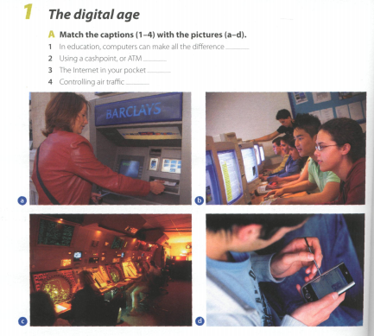**THE DIGITAL AGE**

**A . Match the captions (1-4) with the pictures ( a-d)**

1 in education , computers can make all the difference A B

2 using a cashpoint

3 the internet in your pocket

4 controlling air traffic

C D

**READING** 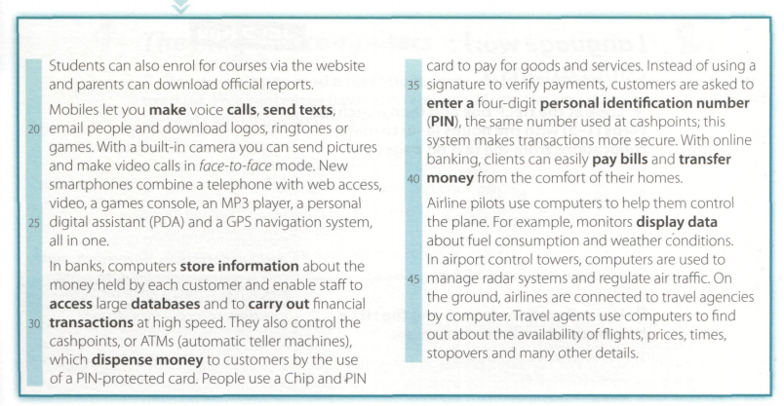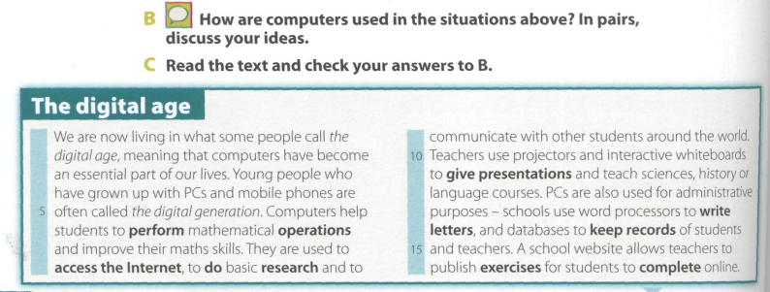

1. **ANSWER**

IN WHAT WAYS DO COMPUTERS HELP STUDENTS?

WHAT DO TEACHERS USE TO GIVE PRESENTATIONS?

HOW ARE COMPUTERS USED FOR ADMINISTRATIVE PURPOSE?

WHAT DOES A SCHOOL WEBSITE ALLOW TEACHERS? AND STUDENTS?

1. **TRUE OR FALSE?**

THE CAMERA IN THE MOBILE PHONES LETS YOU HAVE FACE TO FACE MODE CALLS…………..

GPS means digital assistant ………..

customers have access to bank database……………

the bank staff carry out transactions at high speed……….

computers control cashpoints ………..

cashpoints dispense money to customers by the use of pda……….

**3 choose**

people use a **pda card / pin card** to pay services

clients can pay bills and transfer money from home using **cashpoints / online banking**

pilots know about weather conditions by looking at the **monitor / radar**

**PILOTS / TRAVEL AGENTS** USE COMPUTERS TO FIND OUT INFORMATION ABOUT FLIGHT PRICES, TIMES, STOPOVERS

**4 MATCH THE WORDS WITH THE CORRECT MEANING**

Describes information that is recorded or broadcast using a computer

Collection of facts or figures

Excecute , do

Integrated

Monetary

1-PERFORM (line6)

2-BUILT IN (line 21)

3-DIGITAL (line 25)

4-FINANCIAL ( line 29)

5 DATA (line 42)